**Regular expressions symbol list**

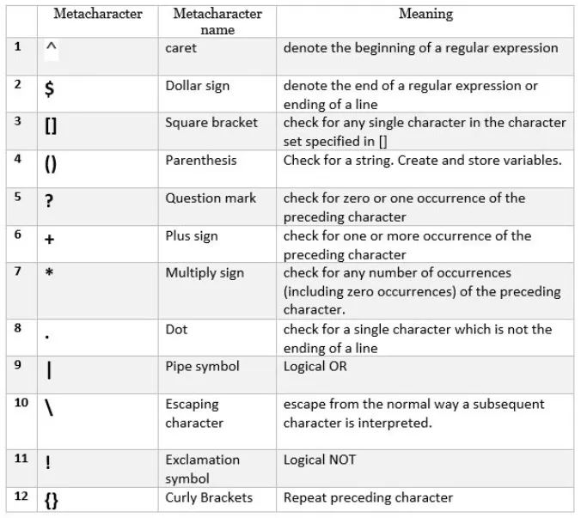

**Linux and its Features :**

Linux is an open-source operating system that manages a computer's resources and allows software to run.

Features :

Open source and free to use

High Customizable and control

Multi-user capability

Strong security

**Kernel :**

In computing, a kernel is the core of an operating system (OS). It acts as a bridge between the hardware and software.

It manages resources like memory, CPU time, and input/output devices.

**Bash : Bourne Again SHell**

Bash is a command-line shell and scripting language commonly used on Linux and other Unix-like operating systems and is used for executing multiple commands and scripts.

**Difference between Linux and Windows**

|  |  |
| --- | --- |
| **Linux** | **Window** |
| Linux is open-source and free | Windows is a paid operating system |
| Linux has machine-friendly features and the user must learn to use Linux | Windows uses Graphical User Interface and any non-technical user can use it without getting into tech-knowledge |
| Linux is less case-sensitive | Windows is not case-sensitive |

**Linux Components**

**Kernel:**

The heart of the Linux system, acting as an interface between the hardware and the rest of the software. It manages memory, processes, file systems, and networking.

**System Libraries:**

Provide reusable code that applications and system utilities use to interact with the kernel and perform various OS functions.

**System Utilities:**

These are programs designed for specific tasks, like managing files, processes, or system settings.

**Is it legal to edit Kernal ? when do you think we have to in case**

Yes, it is legal to edit the Linux kernel. The Linux kernel is released under the General Public License

**What is LILO? Explain**

LILO stands for Linux Loader that is used to load Linux into memory. It can boot operating systems from floppy disks, hard disks, and it does not depend on a specific file system. Lilo handles some tasks such as locate the kernel, identify other supporting programs, load memory and starts the kernel.

**What is shell? How many shells are there and what are they ?**

A shell is a program that provides an interface for interacting with an operating system (OS)

**Bash (Bourne Again Shell):** The most widely used shell, known for its scripting capabilities and features.

**Zsh (Z Shell):** A powerful and customizable shell, often favored for its interactive features and scripting.

**Sh (Bourne Shell):** An older, more basic shell, still used in some scripting contexts.

**Fish (Friendly Interactive Shell):** A modern shell with a focus on ease of use and interactive features.

**C Shell (csh):** Another older shell, known for its syntax and scripting features.

**Korn Shell (ksh):** A shell with features inspired by the C shell and the Bourne shell.

**Tcsh (TENEX C Shell):** A version of the C shell with additional features.

**What is swap space?**

Swap space in Linux is used when the amount of physical memory (RAM) is full. If the system needs more memory resources and the RAM is full, inactive pages in memory are moved to the swap space.

**What is Mount ? how do you mount and unmount file system in Linux**

**Mount :** Mounting is the process of attaching a storage device or partition to a directory or mount point so that its contents can be accessed and managed by computer system users

**What is chmod command ? how to use it**

The chmod command in Linux changes the permissions of files and directories. It allows you to control who can read, write, and execute files, and who can search or use directories in path names.

chmod <options> <permissions> <file_or_directory_name>

Can you add a new user account? Crate a new user in different ways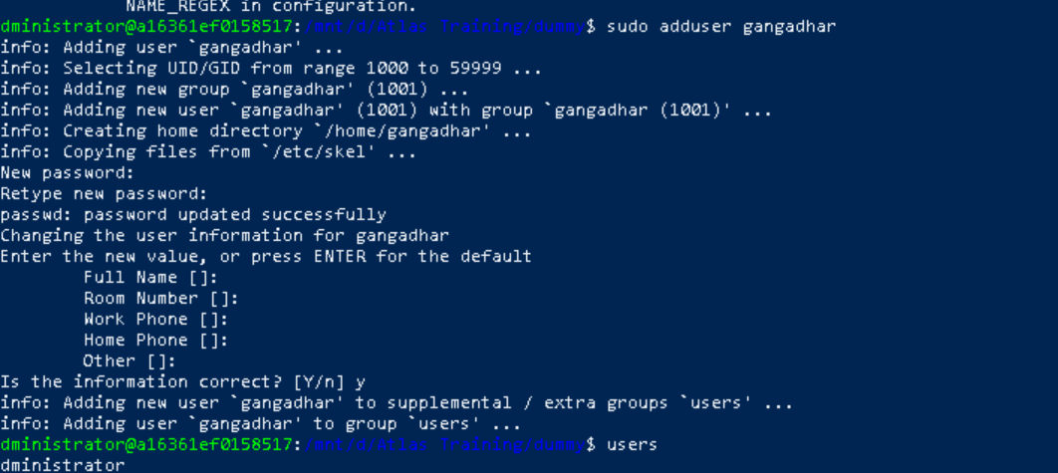

**Can you change the password of a user? How do you do that?**

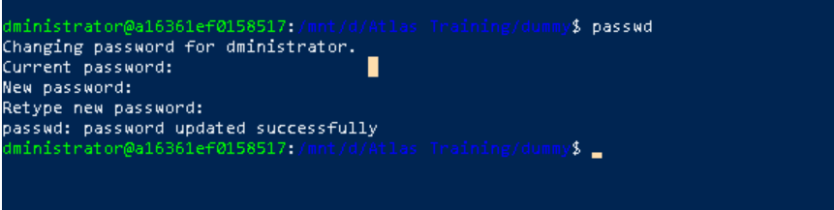

**Process** :

A process is the active execution of a program, using system resources like CPU time and memory.

a **process** represents a program in execution.

**Thread :**

A thread is an independent flow of control that operates within the same address space as other independent flows of control within a process. One process can have multiple threads.

**Diff b/w Process and Thread**

|  |  |
| --- | --- |
| **Process** | **Thread** |
| Independent, separate memory space | Shared memory space with other threads in the same process |
| Heavyweight, consumes more resources | Lightweight, requires fewer resources |
| Slower, involves OS interaction | Faster, often no OS interaction needed |
| Example : A running application (e.g., your web browser) | Example : Multiple tabs or windows within a web browser running concurrently |

**keep a file ready with some content in it for Grep command**

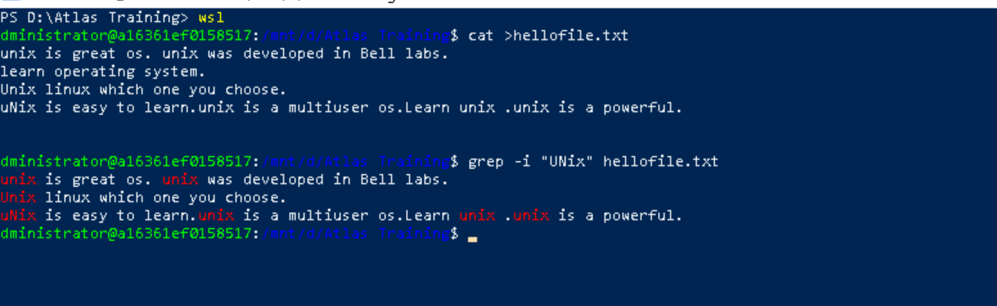

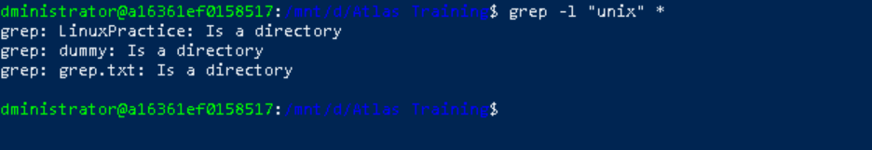

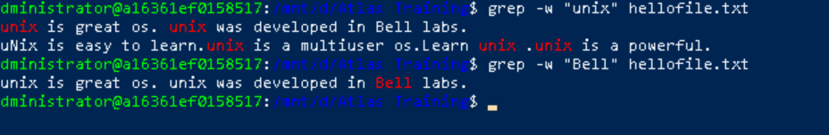

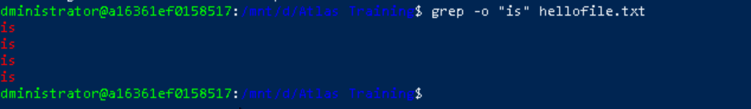



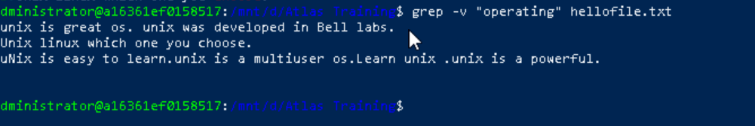

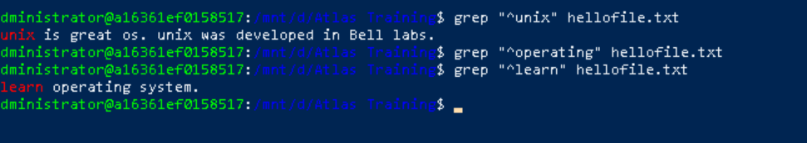

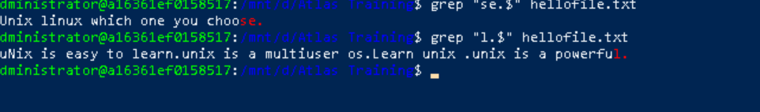

**AWK Commands**

**Print Contents of a File**

The simplest use of AWK command is to print contents of a file to console. Here's how to do it ?

awk '{ print }' input_file

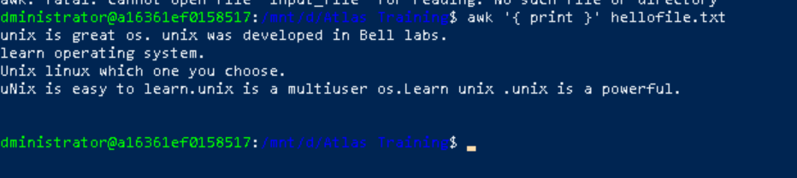

**Print Specific Columns of a File**

One of most common uses of AWK is to extract specific columns from a file. Here's how to extract first and third columns of a file ?

awk '{ print $1, $3 }' input_file

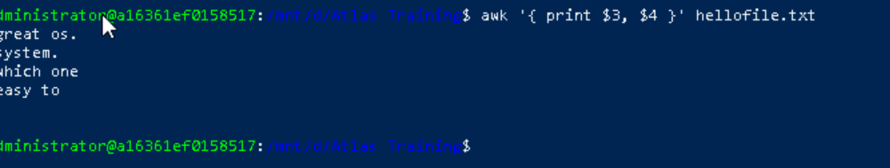

**Filter Lines Based on a Condition**

AWK can also be used to filter lines based on a condition. Here's how to print all lines in a file that contain word "error" ?

awk '/error/ { print }' input_file

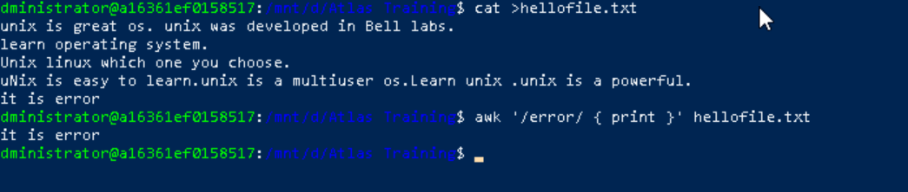

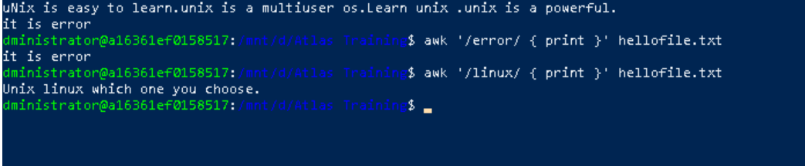

**Sum Values in a Column**

AWK can also be used to perform mathematical operations on data. Here's how to sum values in second column of a file ?

awk '{ sum += $2 } END { print sum }' input_file

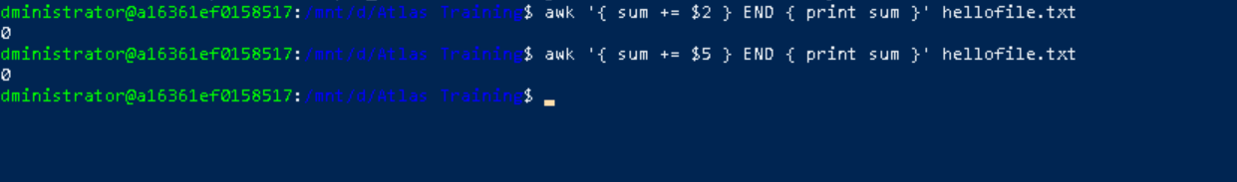

There is no mathematical expressions in my file, so it is showing 0.

**Extract Substring from a Column**

Another common task is to extract a substring from a column in a file. Here's how to extract first three characters from first column of a file ?

awk '{ print substr($1, 1, 3) }' input_file

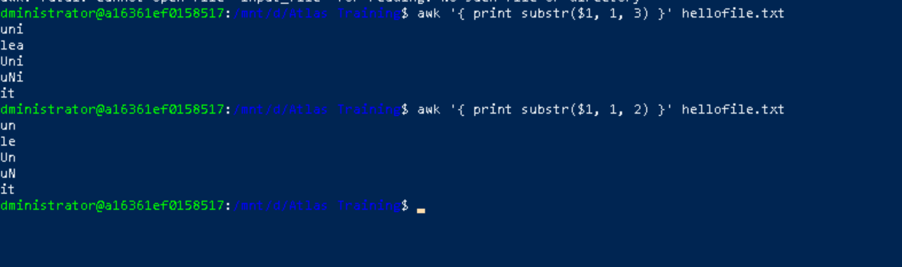

**Replace a String in a File**

To replace a string in a file using AWK command, use following syntax ?

$ awk '{ gsub("oldstring", "newstring") } 1' filename

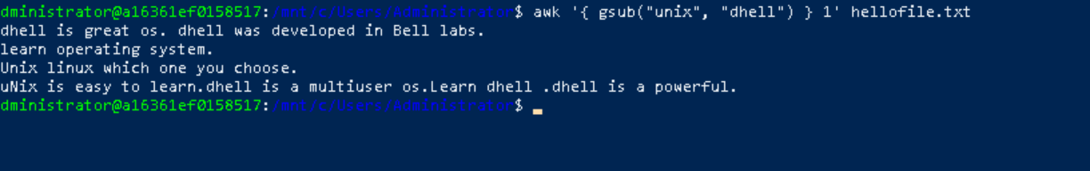

**Display Last Field of a File**

To display last field of a file using AWK command, use following syntax ?

$ awk '{ print $NF }' filename

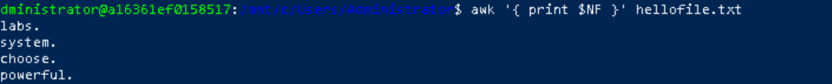

Variables can be used in AWK command to store values that can be used in actions. Here's an example that demonstrates use of variables ?

$ awk '{ total += $1 } END { print "Total: ", total }' filename

Here, variable total is used to store sum of values in first column.



**Using Regular Expressions**

Regular expressions are a powerful feature of AWK command that allows users to search for patterns in data. Here's an example that demonstrates use of regular expressions ?

$ awk '/pattern/ { print }' filename

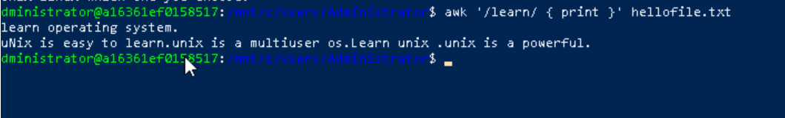

**Using Control Statements**

Control statements such as if-else and while loops can be used in AWK command to perform conditional operations. Here's an example that demonstrates use of if-else statements ?

$ awk '{ if ($1 > 50) { print "Pass" } else { print "Fail" } }' filename

Here, if value in first column is greater than 50, output will be "Pass," otherwise it will be "Fail."

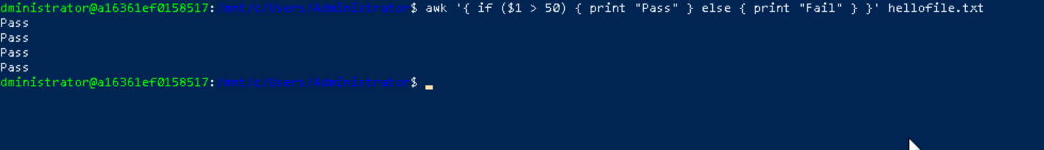

**Using Functions**

Functions can be defined and used in AWK command to perform complex operations. Here's an example that demonstrates use of functions ?

$ awk 'function square(x) { return x*x } { print square($1) }' filename

Here, function square is defined and used to calculate square of value in first column

**Symbolic link**

